**Deployment of Serverless Application on AWS**

**Table of Contents**

1. Introduction
2. Architecture Overview
3. Components and Services

* Amazon S3
* Amazon CloudFront
* Amazon Route 53
* AWS Lambda
* Amazon DynamoDB

1. Deployment Process
2. Security and Best Practices
3. Cost Management
4. Conclusion

Project Description: -   
In this Project, we will build a serverless web application using AWS Lambda, DynamoDB and S3. The application will allow users to create, read, update, and delete (CRUD) items from Dynamo DB table.

1. **Introduction**

This document provides a detailed overview of deploying a serverless web application using AWS services. It aims to outline the architecture, components, deployment process, security considerations, and cost management strategies.

1. **Architecture Overview**

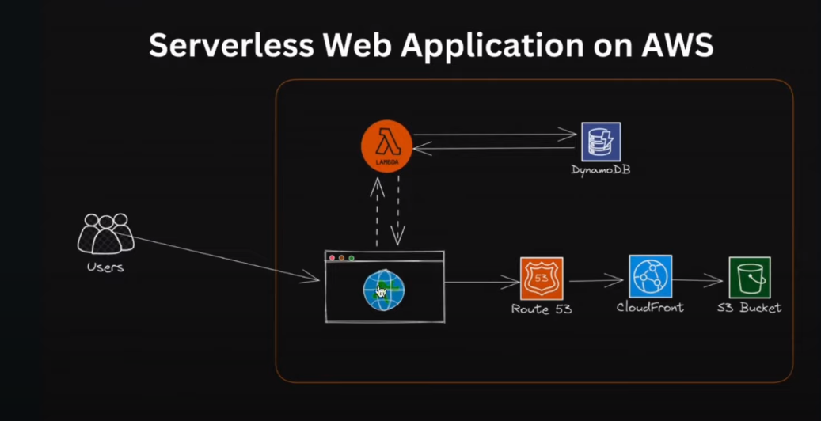

The serverless web application leverages various AWS services to ensure scalability, high availability, and cost efficiency.

The architecture consists of the following key components:

* **Users**: End users who interact with the web application.
* **S3 Bucket**: Stores static assets (HTML, CSS, JavaScript).
* **CloudFront**: Distributes content globally with low latency.
* **Route** **53**: DNS service to route user requests.
* **Lambda**: Executes backend code without provisioning servers.
* **DynamoDB**: NoSQL database for storing application data.

1. **Components and Services**

**Amazon S3**

Amazon Simple Storage Service (S3) is used to store static website content, such as HTML, CSS, and JavaScript files. S3 provides high durability, availability, and scalability for static content.

**Setup Steps:**

**Create an S3 bucket.**

Click on Create Bucket.

**Upload static files to the bucket.**

Click on Upload.

**Configure the bucket to host a static website.**

**S3 bucket 🡪 properties.**

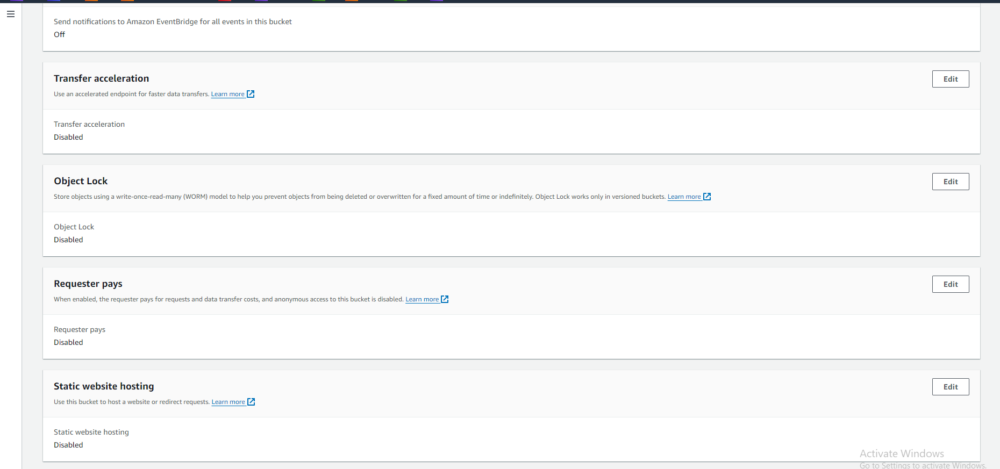

**Edit and enable static website hosting.**

**Amazon CloudFront**

Amazon CloudFront is a content delivery network (CDN) that caches content at edge locations to reduce latency and improve load times for users.

**Setup Steps:**

**Create a CloudFront distribution🡪Specify the S3 bucket as the origin.**  
  
Create a new OAC

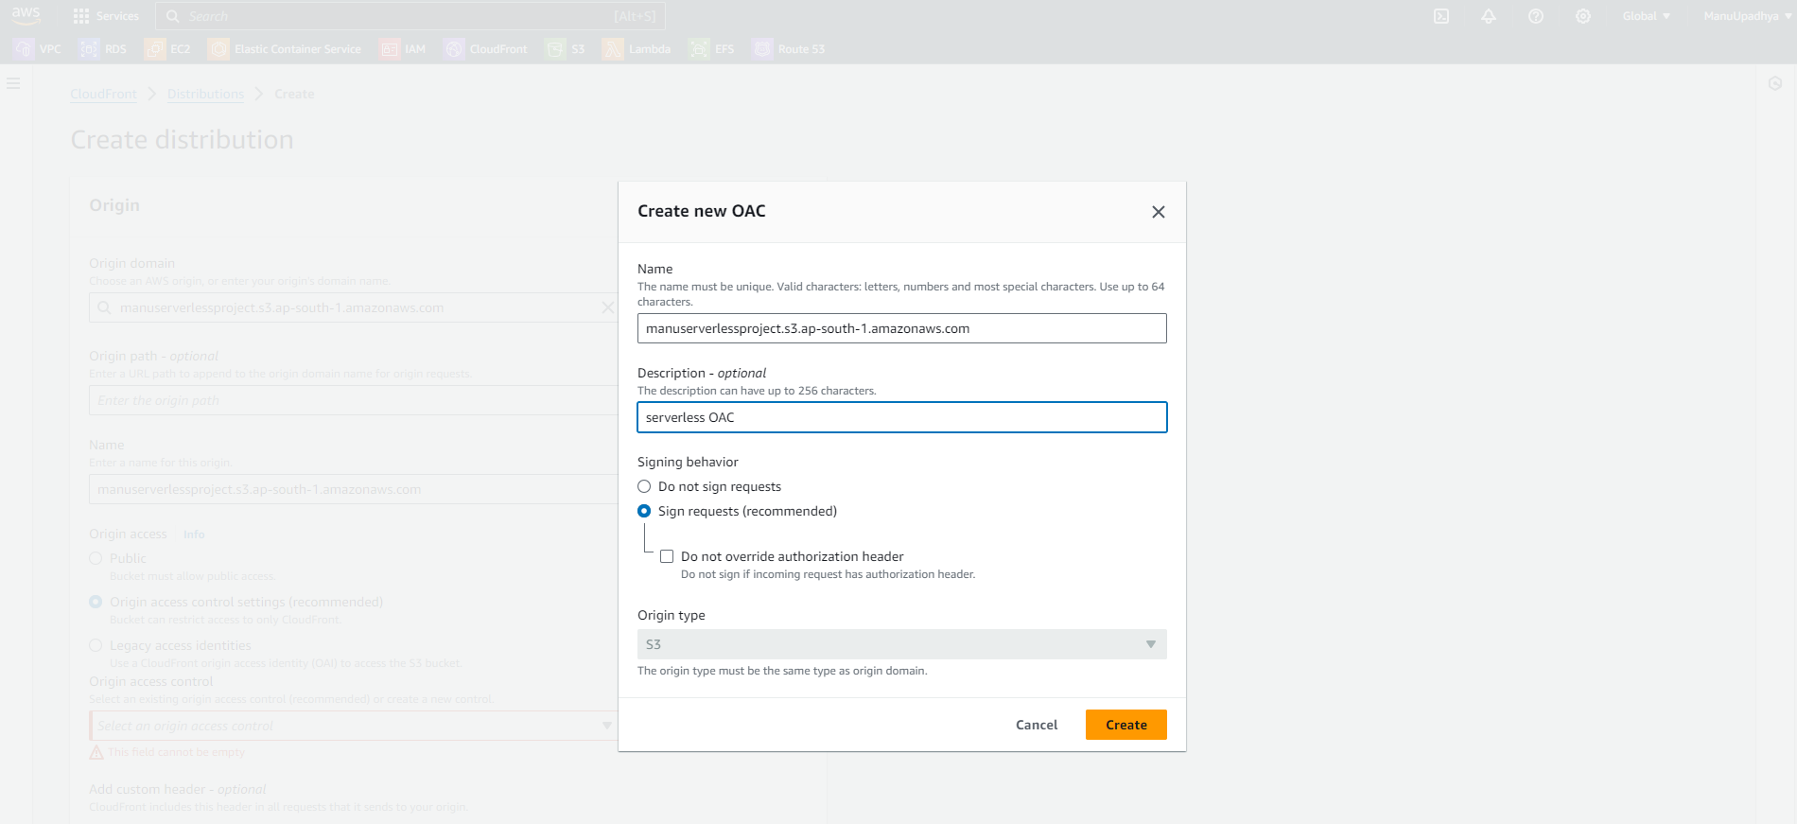  
  
Click on create, select the created OAC.

Leave everything default and click on create Distribution.

**Configure caching policies and distribution settings.**

Get inside the distribution🡪 origins🡪Select the created origin, click on edit.

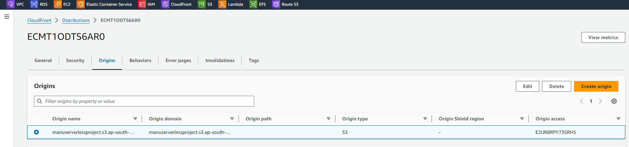

Click on copy policy. We need to paste this in our Amazon S3 bucket.

Created S3 bucket 🡪 Permissions 🡪 Edit bucket Policy and Paste the copied Policy.

Save changes. Adding Policies is Completed.

In CloudFront Distribution settings set root object as **index**.**html**

**Amazon Route 53**

Amazon Route 53 is a scalable DNS and domain name registration service. It routes user requests to the CloudFront distribution.

**Setup Steps:**

**Register a domain or use an existing domain.**

I already have a domain name so I will be using the same domain.

**Create a hosted zone for the domain.**

I already have a hosted zone created previously I will be using the same.

**Configure DNS records to point to the CloudFront distribution.**

Navigate to CloudFront🡪edit settings,

Click on add item. And give the domain name.

Request SSL Certificate.

Create a SSL Certificate using Amazon Certificate Manager.

It will take some time to get certificate.

We need to validate the certificate by creating a DNS Record.

Go inside certificate,

Click on create a record in Route53.

Now status changed to issued.

Select the certificate from the cloud front distribution page.

Click on Save changes.

We need to create a record for our domain that is for (**greetings**.manojupadhya.in) Navigate to Route 53 to create Record.

Add greeting.manojupadhya.in to direct to CloudFront distribution.

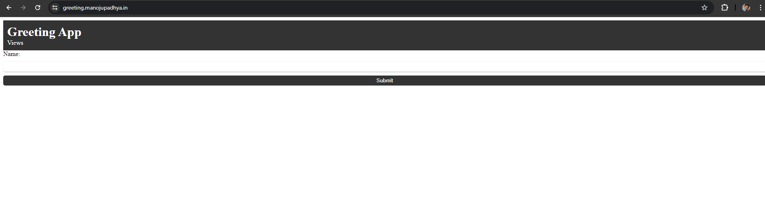

Amazon DynamoDB

Amazon DynamoDB is a fully managed NoSQL database service that provides fast and predictable performance with seamless scalability.

**Setup Steps:**

**Create a DynamoDB table to store application data.**

Navigate to DynamoDB from management console.

Click on the create table.

Rest are default click on create.

Now navigate inside the table🡪Actions🡪 Create Item.

**Now we will create an IAM Role with access to Lambda functions.**

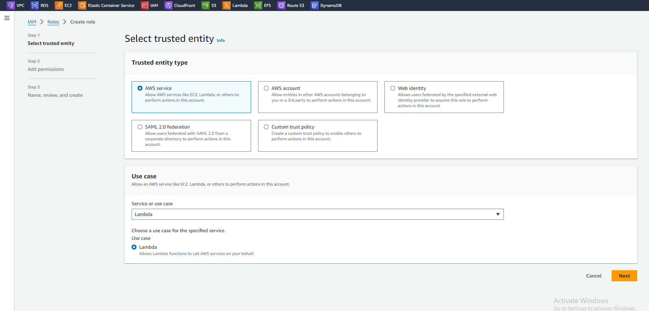

Click on next

Created role.

**AWS Lambda**

AWS Lambda allows running code without provisioning or managing servers. It executes backend logic in response to events, such as HTTP requests.

**Setup Steps:**

**Write and test Lambda functions. Integrate Lambda functions with DynamoDB to perform view operations.**

Navigate to AWS Lambda

Create function

Advanced settings enable function URL.

Attach created IAM role to this function by navigating to configurations🡪Permissions

Select our role which is required for the project.

Adding code for lambda function.

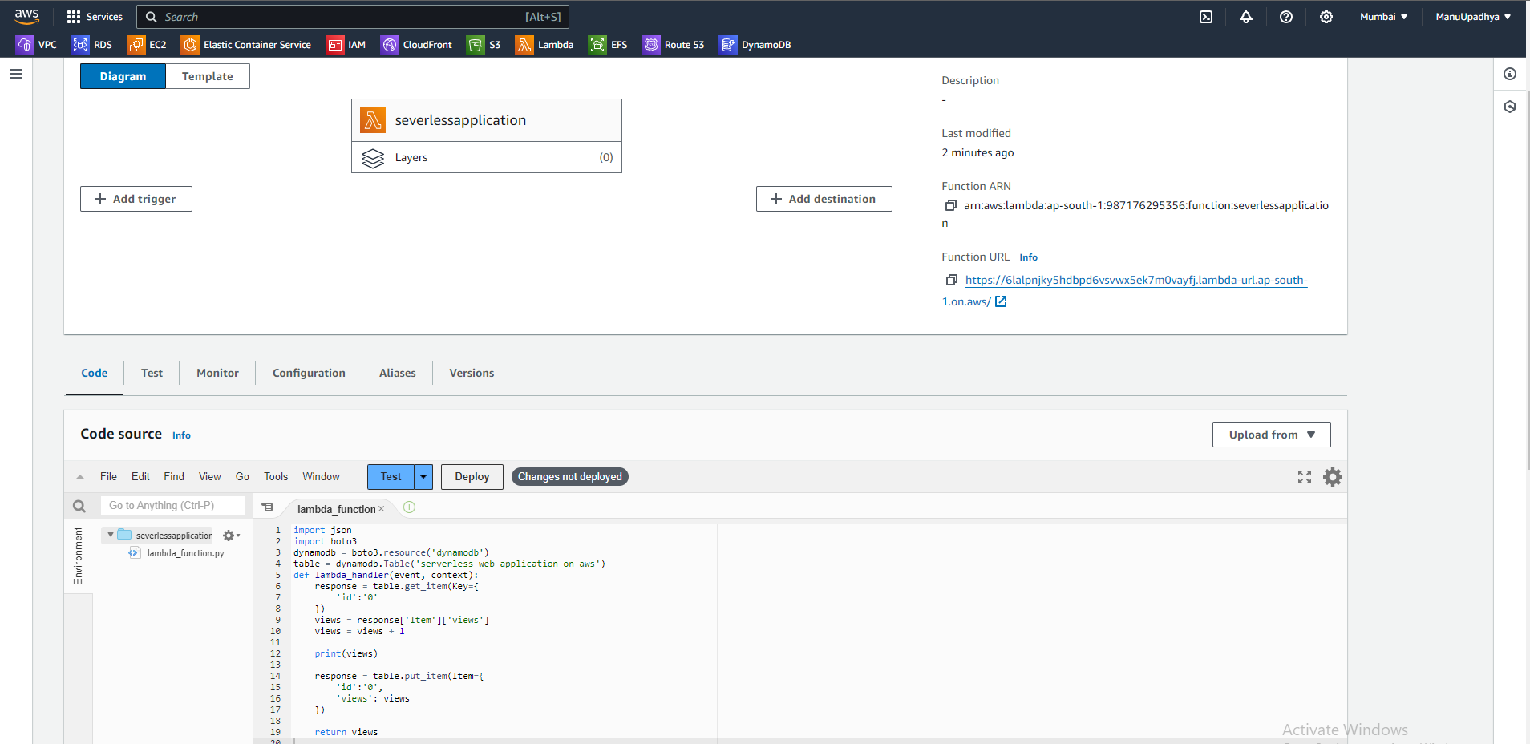

Deploy and test it again.

When test the lambda function view must be incremented as below: -

The updated view count in DynamoDB table.

Code for Lambda function is uploaded, we need function to calculate views or website visits count.  
  
Our work is almost finished…….  
 **Now changes in website code to get view counter to display in web page.**

**Add the lamda function URL in script.js file.**

**Do Not forget to update the code file in S3 bucket, upload these files again….**

**TESTING…….  
  
  
Open the DNS name of the Website…..**

1. **Deployment Process**

Step 1: Set Up S3 Bucket

Create an S3 bucket.

Enable static website hosting.

Upload static files (index.html, style.css, app.js).

Step 2: Configure CloudFront Distribution

Create a CloudFront distribution.

Set the origin to the S3 bucket.

Configure caching behavior and distribution settings.

Step 3: Set Up Route 53

Register or use an existing domain.

Create a hosted zone.

Add DNS records pointing to the CloudFront distribution.

Step 4: Develop and Deploy Lambda Functions

Write backend code for Lambda.

Deploy Lambda functions using the AWS Management Console or CLI.

Set up API Gateway to expose Lambda endpoints.

Step 5: Integrate with DynamoDB

Create a DynamoDB table.

Write Lambda functions to interact with DynamoDB (CRUD operations).

Ensure proper IAM roles and permissions.

**5. Security and Best Practices**

**Security**

Use IAM roles and policies to restrict access.

Enable encryption for S3 and DynamoDB.

Implement WAF (Web Application Firewall) for CloudFront.

Use HTTPS for secure data transmission.

**Best Practices**

Optimize Lambda function performance.

Implement error handling and logging.

Monitor application using AWS CloudWatch.

Automated deployment with AWS SAM or CloudFormation.

**6. Cost Management**

Use AWS Cost Explorer to monitor usage.

Set up billing alerts and budgets.

Optimize resource usage (e.g., Lambda memory allocation, DynamoDB read/write capacities).

**7. Conclusion**

Deploying a serverless web application on AWS offers scalability, high availability, and cost efficiency. By leveraging services like S3, CloudFront, Route 53, Lambda, and DynamoDB, you can build robust applications with minimal management overhead. Proper planning and adherence to best practices ensure secure, efficient, and cost-effective deployments.

Top of Form

Bottom of Form